PROGRAM 8 (CO3)

AIM : Implement Options menu to navigate to activities

XML

*<?*xml version="1.0" encoding="utf-8"*?>*<menu xmlns:android="http://schemas.android.com/apk/res/android"  
 xmlns:app="http://schemas.android.com/apk/res-auto">  
 <item android:id="@+id/item1"  
 android:title="item1"  
 android:icon="@drawable/ic_icon1"  
 app:showAsAction="always" />  
 <item android:id="@+id/item2"  
 android:title="item2"  
 android:icon="@drawable/ic_icon2"  
 app:showAsAction="always" />  
 <item android:id="@+id/item3"  
 android:title="item3"  
 android:icon="@drawable/ic_icon3"  
 app:showAsAction="always" />  
 <item android:id="@+id/item4"  
 android:title="item4"  
 app:showAsAction="never" />  
 <item android:id="@+id/item5"  
 android:title="item5"  
 app:showAsAction="never" />  
 <item android:id="@+id/item6"  
 android:title="item6"  
 app:showAsAction="never" />  
</menu>

JAVA

package com.example.menu;  
  
import androidx.appcompat.app.AppCompatActivity;  
  
import android.content.Intent;  
import android.os.Bundle;  
import android.view.ContextMenu;  
import android.view.Menu;  
import android.view.MenuInflater;  
import android.view.MenuItem;  
import android.view.View;  
import android.widget.PopupMenu;  
import android.widget.Toast;  
  
public class MainActivity extends AppCompatActivity {  
  
 @Override  
 protected void onCreate(Bundle savedInstanceState) {  
 super.onCreate(savedInstanceState);  
 setContentView(R.layout.*activity_main*);  
 }  
  
 @Override  
 public boolean onCreateOptionsMenu(Menu menu) {  
 MenuInflater inflater = getMenuInflater();  
 inflater.inflate(R.menu.*menu_file*, menu);  
 return true;  
 }  
  
 @Override  
 public boolean onOptionsItemSelected(MenuItem item) {  
 switch (item.getItemId()) {  
 case R.id.*item1*:  
 Intent i=new Intent(getApplicationContext(),MainActivity2.class);  
 startActivity(i);  
 return true;  
 case R.id.*item2*:  
 Intent i2=new Intent(getApplicationContext(),MainActivity3.class);  
 startActivity(i2);  
 return true;  
 case R.id.*item3*:  
 Intent i3=new Intent(getApplicationContext(),MainActivity4.class);  
 startActivity(i3);  
 return true;  
 case R.id.*item4*:  
 Toast.*makeText*(MainActivity.this, "Item4 Selected", Toast.*LENGTH_SHORT*).show();  
 case R.id.*item5*:  
 Toast.*makeText*(MainActivity.this, "Item5 Selected", Toast.*LENGTH_SHORT*).show();  
 case R.id.*item6*:  
 Toast.*makeText*(MainActivity.this, "Item6 Selected", Toast.*LENGTH_SHORT*).show();  
 default:  
 return super.onOptionsItemSelected(item);  
 }  
 }  
}

OUTPUT

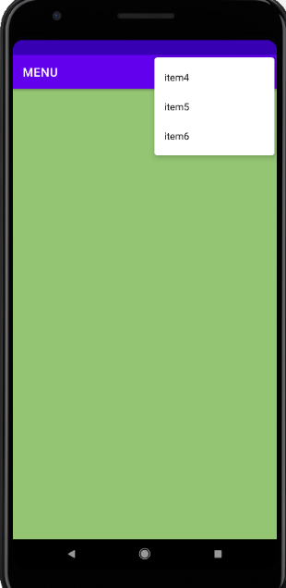

RESULT : Program to implement options menu to navigate to activities successfully executed and output verified